B – K-Means

Assignment

Intro
Customer Segmentation can be a powerful means to identify unsatisfied customer needs. This technique can be used by companies to outperform the competition by developing uniquely appealing products and services.
Customer Segmentation is the subdivision of a market into discrete customer groups that share similar characteristics. Customer Segmentation can be a powerful means to identify unsatisfied customer needs. Using the above data companies can then outperform the competition by developing uniquely appealing products and services.
The most common ways in which businesses segment their customer base are:
- Demographic information, such as gender, age, familial and marital status, income, education, and occupation.
- Geographical information, which differs depending on the scope of the company. For localized businesses, this info might pertain to specific towns or counties. For larger companies, it might mean a customer’s city, state, or even country of residence.
- Psychographics, such as social class, lifestyle, and personality traits.
- Behavioral data, such as spending and consumption habits, product/service usage, and desired benefits.

Provided Files
We have a supermarket mall and through membership cards , you have some basic data about your customers like Customer ID, age, gender, annual income and spending score. The file consist of informations from 200 customers.
To download file, you can go to the following URL:
https://ndquy.github.io/assets/docs/Mall_Customers.csv

K Means Clustering Algorithm
To perform k-means algorithm, do the following steps:
- Specify number of clusters K.
- Initialize centroids by first shuffling the dataset and then randomly selecting K data points for the centroids without replacement.
- Keep iterating until there is no change to the centroids. i.e assignment of data points to clusters isn’t changing.

Find the optimal number of cluster K
To find the number of cluster K, you can use WCSS value. WCSS measures sum of distances of observations from their cluster centroids which is given by the below formula.

$$WCSS= \sum_{i ∈n}{{(X_{i}-y_{i}) }^{2}}$$
where Y_{i} is centroid for observation X_{i}. The main goal is to maximize number of clusters and in limiting case each data point becomes its own cluster centroid.
Detailly, For each k value, we will initialise k-means and use the inertia attribute to identify the sum of squared distances of samples to the nearest cluster centre.
As k increases, the sum of squared distance tends to zero. Imagine we set k to its maximum value n (where n is number of samples) each sample will form its own cluster meaning sum of squared distances equals zero.
Below is a plot of sum of squared distances for k in the range specified above. If the plot looks like an arm, then the elbow on the arm is optimal k.

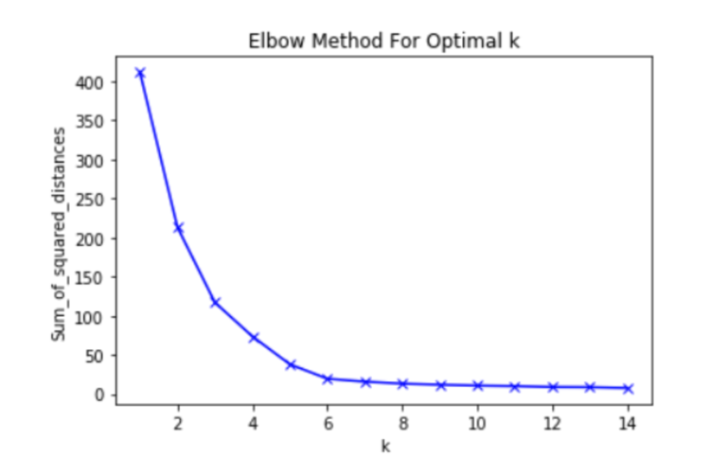
In the plot above the elbow is at k=5 indicating the optimal k for this dataset is 5.

The Algorithm
The k-means clustering algorithm is as follows:
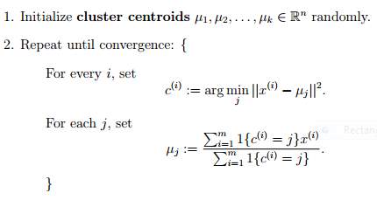

Requirements
To complete this assignment you will need to use python to write a program the uses the k-means algorithm described above to predict clusters the provided data. This program must run on the google colab with requirements:

- Implement K-means using numpy only, do not use any machine learning library.
- Find the optimal k – cluster
- Run k-means with the optimal k.
- Visualizing K-Means Clustering results to understand the clusters.
- Make understanding about the data after clustering.

